School Crest

School Name

MATHEMATICS

March 2001

General Instructions  Reading time - 5 minutes  Working time - 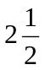 Hours  Write using blue or black pen  Board-approved calculators may be used  A table of standard integrals is provided  All necessary working should be shown in every question | Total marks(96)  Attempt questions 1 – 8  All questions are of equal value

Question: 1

a) Evaluate 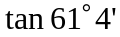 correct to 3 significant figures 2

b) Solve 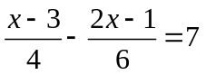 3

c) Find integers x and y such that 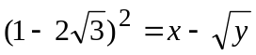 2

d) Solve 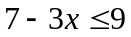 and graph on a number line 3

- AB is an interval on the number plane. The point A has coordinates (-1, 4).
X is the mid-point of AB and has coordinates (3, 2). Find the coordinates of B. 2

Marks

Question 2

a) Find

(i) 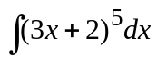 1

(ii) 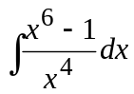 2

b) In the triangle ABC, the side AC has length 5cm and the angles B and C are 70° and 60° respectively.
B
Copy the triangle ABC

70

A
C
60

5

Determine (to three significant figures) the length AB. 2

(Question 2 continued over the page)
Marks
c)
C
(6,6)

(0,4)

B

(2,0)
A

The points A,B and C have coordinates (2,0), (0,4) and (6,6) and AC = 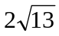 units.

The angle between the line AB and the x-axis is .

Copy the diagram.

(i) Find the gradient of AC 1

(ii) Show the equation of the line AC is 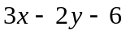 = 0 2

(iii) Find the size of the angle to the nearest degree. 1

(iv) Find the perpendicular distance from point B to the line AC 2

(v) Hence or otherwise, calculate the area of  1
Marks

Question 3

a) Differentiate the following
(i) 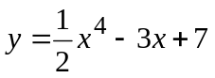 1

(ii) 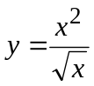 2

(iii) 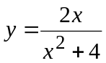 2

b) For the curve represented by the equation 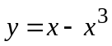

(i) Find  1

(ii) Find the equation of the tangent to the curve at the point (1,0) 2

(iii) State the gradient of the normal at this point. 1

c) (i) Copy and complete the identity 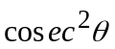 - 1 =… 1

(ii) Prove that 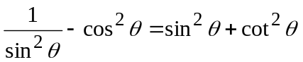 2

Marks

Question 4

a) A geometric sequence has a second term 6 and the ratio of the seventh term to the sixth term is 3. Find the first term.
2

b) A labourer is stacking pipes. The pipes are stacked in layers, where each layer contains one pipe less than the layer below. There are five pipes in the top layer, six pipes in the next and so on. There are n layers altogether.

(i) Write down the number of pipes in the bottom layer. 1

(ii) Show that there are 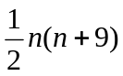 pipes in the stack. 2

c) Find the values for p for which 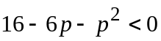 2

d)
(i) Find the points of intersection of the line 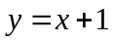 with the parabola 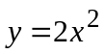
1

(ii) Find the area enclosed between this line and the given parabola. 2

(iii) For what values of m does the line 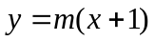 have no intersection with the parabola ?
2
Marks
Question 5

a) If 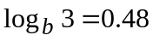 and 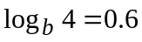, evaluate 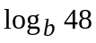 1

b) (i) Find the equation of the normal to the curve 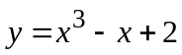 and 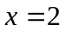 3

(ii) Find the point of intersection of the normal and the x-axis 1

c) Below is given the graph of 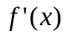

Copy the number plane below and sketch a possible graph of 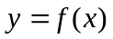 2

d) Given the equation 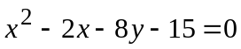

(i) Show that 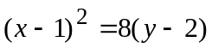 2

(ii) Find the focus 1

(iii) Find the vertex 1

(iv) Find the equation of the directrix 1

Question: 6

- Consider the curve given by 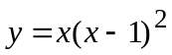

(i) Show 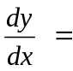 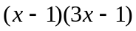. 2

(ii) Find the coordinates of the two stationary points. 2

(iii) Determine the nature of the stationary points. 2

(iv) Find any points of inflection . 2

(v) Sketch the curve. 2

b) The gradient function of a curve is given by 2x-3. Find the equation of the curve if it passes through the point (1,5) | 2

Question 7 | Marks
a)  (i) For what values of r does the geometric series 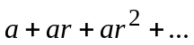 have a limiting sum? | 1
(ii) To what sum will $1500 amount if invested for 3 years at 12% p.a. compounded annually? | 2
(iii) Find the limiting sum of the series  60 – 30 + 15 - …. | 2
b) If 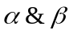 are the roots of the equation 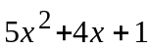= 0 , without solving the equation find the value(s) of:  (i) 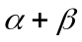 | 1
(ii) 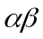 | 1
(iii) 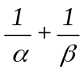 | 1
(iv) 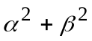 | 2
c) Solve (x + 2)(3 - x) >0 | 2

Question 8 | Marks
a) Solve the equation 2 sin x = √3 where 0⁰ < x < 360⁰ | 2
b) Consider the function :  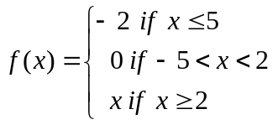  Find :  (i) f(-6) + f(1) + f(6) | 1
(ii) f(a² + 2) | 1
c) (i) Sketch the function y = x² for 0 < x < 2 and write down the range . | 2
(ii) If y in part (i) is part of an odd function defined for -2 < x < 2 , sketch , on a second diagram, the function f(x). | 1
d) Differentiate 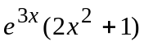 | 2
b)  (i) Complete the following table for y =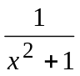  x  0  0.25  0.5  0.75  1  (ii) Hence evaluate 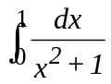 using the trapezoidal rule and two sub intervals. | 1  2

END OF PAPER
Marks

Question | Marks | Content | Syllabus outcomes | Targeted performance bands
1(a) | 2 | Linear Functions and Lines | P4 | 2 – 3
1(b) | 2 | Basic Arithmetic and Algebra | P3 | 2 – 3
1(c) | 2 | Basic Arithmetic and Algebra | P3, P4 | 2 – 3
1(d) | 2 | Basic Arithmetic and Algebra | P3, P4 | 2 – 3
1(e) | 2 | Basic Arithmetic and Algebra | P3, P4 | 2 – 3
1(f) | 2 | The Trigonometric Functions | H5 | 2 – 3
2(a)(i) | 2 | Integration | P3, H8 | 3 – 4
2(a)(ii) | 2 | The Trigonometric Functions | H8 | 3 – 4
2(b)(i) | 1 | Linear Functions and Lines | P4 | 2 – 3
2(b)(ii) | 1 | Linear Functions and Lines | P4 | 2 – 3
2(b)(iii) | 1 | Linear Functions and Lines | P4 | 2 – 3
2(b)(iv) | 1 | Plane Geometry; Linear Functions and Lines | P4 | 2 – 3
2(b)(v) | 2 | Linear Functions and Lines; Plane Geometry | P4 | 2 – 4
2(b)(vi) | 2 | Linear Functions and Lines; Trigonometric Ratios | P4 | 2 – 4
3(a)(i) | 2 | The Tangent to a Curve and the Derivative of a Function; The Trigonometric Functions | P7, H5 | 2 – 3
3(a)(ii) | 2 | The Tangent to a Curve and the Derivative of a Function; Logarithmic and Exponential Functions | P7, H3 | 3 – 4
3(b) | 4 | Geometrical Applications of Differentiation | P4, P6, P7, H6 | 3 – 5
3(c)(i) | 2 | Trigonometric Ratios | P4 | 2 – 3
3(c)(ii) | 2 | Plane Geometry | P2, P4 | 2 – 3
4(a) | 2 | Series and Applications | H5 | 3 – 4
4(b)(i) | 1 | Series and Applications | H4, H5 | 3 – 4
4(b)(ii) | 2 | Series and Applications | H4, H5 | 3 – 5
4(b)(iii) | 2 | Series and Applications | H4, H5 | 3 – 5
4(c)(i) | 1 | The Quadratic Polynomial and the Parabola | P4 | 2 – 3
4(c)(ii) | 2 | Integration | H8 | 3 – 4
4(c)(iii) | 2 | Real Functions of a Real Variable and Their Geometrical Representation | P4 | 3 – 4
5(a)(i) | 1 | The Tangent to a Curve and the Derivative of a Function | P7 | 2 – 3
5(a)(ii) | 3 | Geometrical Applications of Differentiation | P4, H6 | 3 – 4
5(a)(iii) | 2 | Geometrical Applications of Differentiation | P6, H6 | 3 – 4
5(a)(iv) | 2 | Geometrical Applications of Differentiation | P5, H6, H9 | 3 – 4
5(b) | 2 | Logarithmic and Exponential Functions | H3 | 3 – 5
5(c) | 2 | Integration | H8 | 3 – 4
6(a)(i) | 1 | Applications of Calculus to the Physical World | H3, H4 | 2 – 3
6(a)(ii) | 2 | Applications of Calculus to the Physical World | H3, H4 | 3 – 5
6(a)(iii) | 2 | Applications of Calculus to the Physical World | H3, H4 | 3 – 5
6(a)(iv) | 2 | Applications of Calculus to the Physical World | H3, H4 | 3 – 5
6(b)(i) | 2 | Linear Functions and Lines | P4 | 3 – 4
6(b)(ii) | 1 | Plane Geometry | P2 | 3 – 4
6(b)(iii) | 2 | Plane Geometry | H2, H5 | 3 – 5
7(a)(i) | 1 | Series and Applications | H4 | 3 – 4
7(a)(ii) | 1 | Series and Applications | H4 | 4 – 5
7(a)(iii) | 3 | Series and Applications | H4, H5 | 4 – 6
7(b)(i) | 1 | Applications of Calculus to the Physical World | H5 | 3 – 4
7(b)(ii) | 1 | Applications of Calculus to the Physical World | H4, H5 | 3 – 4
7(b)(iii) | 1 | Applications of Calculus to the Physical World | H4, H5 | 3 – 4
7(b)(iv) | 2 | Applications of Calculus to the Physical World | H4, H5 | 4 – 6
7(b)(v) | 2 | Applications of Calculus to the Physical World | H4, H5 | 5 – 6
8(a)(i) | 1 | Integration; Logarithmic and Exponential Functions | H3, H8, H9 | 4 – 5
8(a)(ii) | 2 | Logarithmic and Exponential Functions | H3 | 2 – 3
8(a)(iii) | 2 | Integration | H8 | 3 – 4
8(b)(i) | 1 | Probability | H4, H5 | 3 – 4
8(b)(ii) | 2 | Probability | H4, H5 | 4 – 5
8(b)(iii) | 2 | Probability | H4, H5 | 4 – 6
8(c) | 2 | Geometrical Applications of Differentiation | H2, H6 | 5 – 6
9(a) | 3 | Integration; The Trigonometric Functions | H8 | 4 – 6
9(b)(i) | 3 | Plane Geometry | H5 | 4 – 6
9(b)(ii) | 1 | Basic Arithmetic and Algebra | P4 | 4 – 5
9(b)(iii) | 2 | Plane Geometry; Basic Arithmetic and Algebra | P4 | 4 – 6
9(b)(iv) | 3 | Geometrical Applications of Differentiation | P7, H2, H5 | 4 – 6
10(a)(i) | 1 | The Trigonometric Functions | P4, H5 | 3 – 4
10(a)(ii) | 2 | The Trigonometric Functions | H5, H9 | 2 – 4
10(a)(iii) | 1 | The Trigonometric Functions | P4, H5 | 4 – 5
10(a)(iv) | 2 | The Trigonometric Functions | P4, H5, H9 | 5 – 6
10(b)(i) | 1 | Plane Geometry | H2, H5 | 3 – 4
10(b)(ii) | 2 | Plane Geometry | H2, H5, H9 | 4 – 6
10(b)(iii) | 3 | Plane Geometry | H2, H5 | 5 – 6

Question 1 (12 marks) Marks

- Evaluate 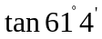 correct to 3 significant figures 2

Outcome assessed: P3

Marking Guidelines
 | Criteria | Marks
 | Correct answer of 1.81 | 2
   | Correct answer/incorrect significant figures. e.g. 1.80, 1.809  Correct radian answer of 5.08 (must be 3 significant figures) | 1

b) Solve 3

Outcomes assessed: P3, P4

Marking Guidelines
 | Criteria | Marks
 | Correct answer 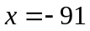 | 3
 | Correct expansion of brackets to obtain 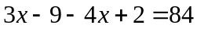 | 2
     | Correctly multiplying by 12 to obtain 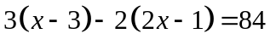  OR  Correctly multiplying by 24 to obtain 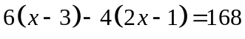  OR  Correct expansion of brackets from incorrect initial step | 1

Sample answer:
1
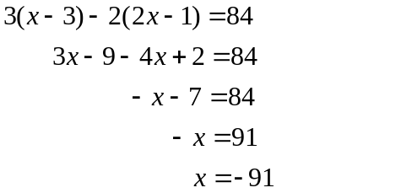
1
1
Marks
c) Find integers x and y such that 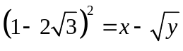 2

Outcomes assessed: P3, P4

Marking Guidelines
 | Criteria | Marks
 | Correct answer 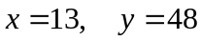 | 2
   | Correct expansion 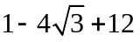  OR  If expansion incorrect, for expressing any surd of the form 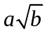  correctly as 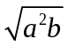 | 1

Sample answer:
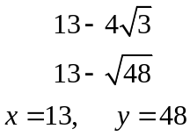

d) Solve 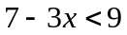 and graph on a number line 3

Outcomes assessed: P3, P4

Marking Guidelines
 | Criteria | Marks
 | Correctly solved and sketched | 3
   | Solved correctly, not sketched  OR  One line of solution correct and sketch correct from incorrect answer | 2
 | Determining 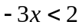 | 1

Sample answer:
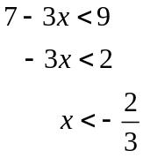
Marks
e) AB is an interval on the number plane. The point A has coordinates (-1, 4).
X is the mid-point of AB and has coordinates (3, 2). Find the coordinates of B 2

Outcomes assessed: P4

Marking Guidelines
 | Criteria | Marks
 | Both coordinates correct (7, 0) | 2
 | One coordinate correct x = 7 OR y = 0 | 1

Sample answer:
B = (7, 0)

Question 6 (12 marks) Marks

- Consider the curve given by 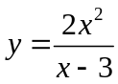 1
- Show 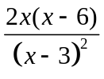.

Outcome Assessed: P7

Marking Guidelines
 | Criteria | Marks
 | Correctly uses “quotient rule” or other recognised method to show  | 1

Sample answer:
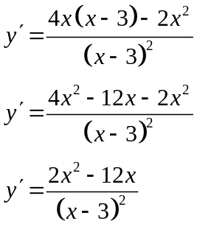

(ii) Find the coordinates of the two stationary points. 3

Outcome Assessed: P4, H6

Marking Guidelines
 | Criteria | Marks
     | Equates derivative to zero  Determines both values of x from the quadratic equation  Calculates correct or consistent y values from their x values for stationary points | 3
   | Equates derivative to zero  Determines both x values for their stationary points | 2
 | Equates derivative to zero | 1

Sample answer:

Stationary points occur when 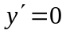
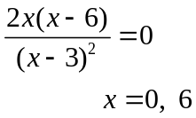
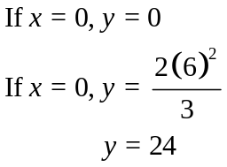
∴ Stationary points are (0, 0) and (6, 24)

(iii) Determine the nature of the stationary points. 2

Outcomes assessed: P6, H6

Marking Guidelines
 | Criteria | Marks
 | Correctly determines the nature of both stationary points, with appropriate working | 2
   | Correctly determines the nature of one stationary point, with appropriate working  OR  Uses appropriate test (correctly done once) involving 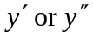 | 1

Sample answer:

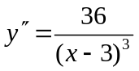

At (0, 0), y” = -1  ∴ (0, 0) is a maximum turning point
At (6, 24), y” = 1 ∴(6, 24) is a minimum turning point

(iv) Determine the two asymptotes. 2

Outcomes assessed: P4, H5

Marking Guidelines
 | Criteria | Marks
 | Correctly determines both asymptotes | 2
 | Correctly determines one asymptotes | 1

Sample solution
 and 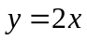 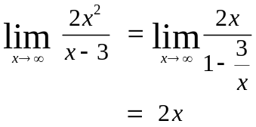

- Sketch the curve. 1

Outcomes assessed: P5, H6, H9

Marking Guidelines
 | Criteria | Marks
 | Correct Sketch for their information showing maximum and minimum and x = 3 | 1

Sample answer:

y

24
•

•
6
x
3

b) In the next “scrabble” contest Mrs. Booth determined the probability of winning
for several of her players.
For three of the girls the probability that each of them wins is, Anne 15%, Betty 21% and Kim 12%.
For two of the boys the probability that each of them wins is, John 29% and Tom 14%.
For the entire team, the probability of a boy winning is 49%.

(i) What is the probability of Betty or Tom winning? 1

Outcomes assessed: H4, H5

Marking Guidelines
 | Criteria | Marks
 | Correct answer given | 1

Sample answer:
P(T or B) = 21 + 14
= 35% (or fraction equivalent)

(ii) What is the probability of a girl other than Betty winning? 2

Outcomes assessed: H4, H5

Marking Guidelines
 | Criteria | Marks
 | Correct answer  P(Girl) = 51%  P(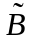) = 51 – 21  = 30% | 2
   | Correct probability for girl. i.e. P(Girl) = 51%  OR  Knew to subtract 21%. i.e. 49 – 21 – 28% | 1

Examination Mapping Grid

Question | Marks | Content | Syllabus  Outcomes | Targeted  Performance  bands
1(a) | 2 | The Trigonometric Functions | P3 | 2 – 3
1(b) | 3 | Basic Arithmetic and Algebra | P3, P4 | 2 – 3
1(c) | 2 | Basic Arithmetic and Algebra | P3, P4 | 2 – 3
1(d) | 3 | Basic Arithmetic and Algebra | P3, P4 | 2 – 3
1(e) | 2 | Linear Functions and Lines | P4 | 2 - 3

Question | Marks | Content | Syllabus  Outcomes | Targeted  Performance  bands
6(a)(i) | 1 | The tangent to a curve and The Derivative of a Function | P7 | 2 – 4
6(a)(ii) | 3 | Geometrical Applications of Calculus | P4, H6 | 3 – 4
6(a)(iii) | 2 | Geometrical Applications of Calculus | P6, H6 | 3 – 4
6(a)(iv) | 2 | Geometrical Applications of Calculus | P4, H5 | 2 – 6
6(a)(v) | 1 | Geometrical Applications of Calculus | P5, H6, H9 | 2 – 5
6(b)(i) | 1 | Probability | H4, H5 | 2 – 3
6(b)(ii) | 2 | Probability | H4, H5 | 2 – 3

